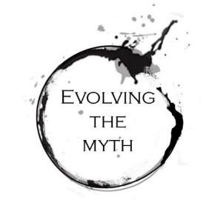

Evolving the Myth

A New Chapter of Grand Narrative Painting for the Public
Over the centuries, millions of travelers have visited destinations throughout the world to experience the grand narrative artworks housed in cathedrals and chapels. Many of these visitors are deeply inspired by these works, regardless of religious affiliation. The impact of these mural-sized paintings is surely amplified by, and inseparable from, the epic surroundings within which they are displayed.
Grand Narrative Epics
Historical, grand narrative paintings can be found in most metropolitan museums. On a trip to the Vatican you can experience Raphael’s 16x25 foot painting "The School of Athens”, painted between 1509 and 1511. Head to Rijksmuseum in the Netherlands and you’ll find Rembrandt’s 16x14 foot masterpiece “The Night Watch”, painted in 1642. Next, you’re off to the Louvre in Paris where you can find many grand narrative epics, such as Delacroix’s 9 x 11 foot “Liberty Leading the People”, painted in 1830. Finally, your trip takes you to Prague, where you experience Mucha’s massive “Slav Epic”: a series of massive paintings, on the order of 27 x 20 feet, created between 1910 and 1928.

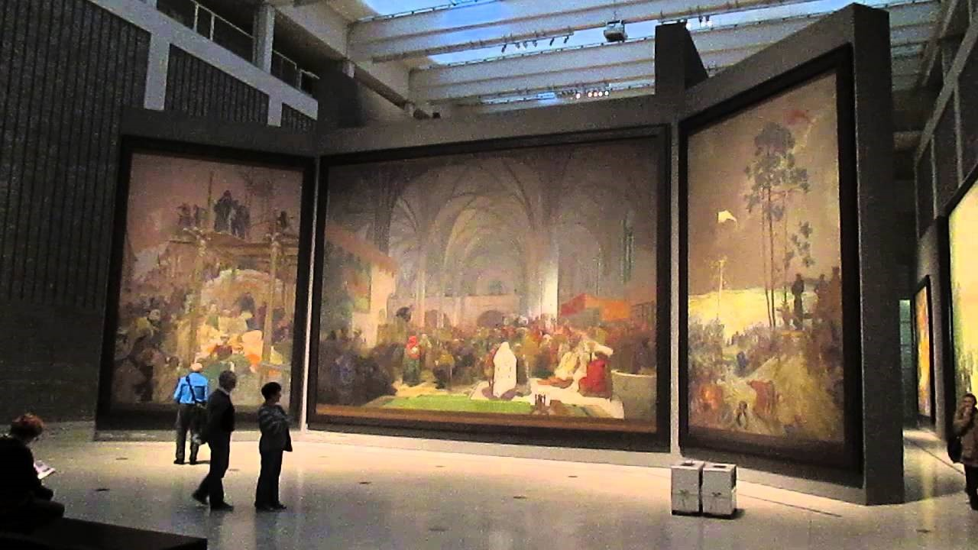
One of Mucha’s monumental paintings in his ‘Slav Epic’ series- an example of a large-scale epic that inspires us.

Why did they stop being created?
From the mid 1400’s Renaissance until Post Modernism in the 20th century, grand narrative paintings were created for and celebrated by the public. Cities and churches, for the most part, commissioned artists and guilds to bring these massive creations to life. Today, museums and galleries are the primary mechanisms that bring art to the people. While it is common for museums to show historical grand narrative paintings, it’s very rare for them to support contemporary work in this category, or for that matter, modern realism in general. Installation, performance, video, photography, and painting of the post-modern aesthetic dominate the museum space for living artists.
Particularly over the last 25 years, coinciding with the expansion of Atelier programs, there has been a resurgence of highly skilled artists who utilize classical painting techniques in their work. Collectively, their art can be described as Modern Realism.
While museums have been mostly unreceptive to modern realist artists, galleries have provided a meaningful conduit for them to reach the public. However, as the imperative of the gallery model is to sell artwork, this has understandably resulted in a creative ecosystem that optimizes work best suited to ‘the living room wall’. While many people might enjoy experiencing an epic-sized, deeply engaging work within a museum setting, acquiring one for their residence is another story.
Simply put, selling epic-sized paintings of dramatic engagement in the gallery setting is a hard sell.
This dual problem of museum unreceptivity and limited salability in galleries has created a gap in our contemporary artistic ecosystem. Luckily, there are some notable exceptions that have been the oases of our time, such as shows and events put on by the Art Renewal Center, European Museum of Modern Art, Figurative Art Convention & Expo, and others.
While there isn’t a lack of talent, there is a lack of venues and incentives among artists to produce grand narrative epics. We believe the problem is mostly logistical in nature. Given the appetite of the public to see this genre of historical painting, shouldn’t we give them the next installment in the series?

Evolving the Myth
Within this movement of highly skilled artisans we believe there is an imbalance of skill vs. meaning. With the growing demand for quickly digestible digital click-bait, most artists are thrown into a highly competitive digital landscape. In this setting, the priority is to feed an overstimulated viewer with the most shocking, fantastical imagery possible. Depth is a fleeting characteristic.
As we continue to search for meaning, and a shared vision for humanity, we need to ask, “What more is needed?” The overabundance of ‘empty images’ that display skill alone can also leave one feeling incomplete.
We believe that there is a great responsibility and potential for the contemporary artist to fill within our society: to manifest great works of art that not only display exceptional skill, but are also wrought with meaning and narrative. The artist has the potential to act as a sail for culture, and can help steer our journey towards greater collective understanding.
Through story, myth and symbol, artists have always wrestled with the unknown aspects of humanity, striving to open portals that transcend our current known reality. Contemporary makers of large-scale narrative paintings carry the capacity to act as modern-day shamans.
Our goal is to renew how art is known through Narrative Realism and provide the public with exceptional, educational, and transcendent experiences.

Combining Epic Paintings Within Immersive Environments
Imagine a space that renews the awe and wonder found in European cathedrals and the monastic temples of the East, enmeshed with the modern lens of story, aesthetic, and grandeur. In this space, these worlds combine to create a container for the viewer to journey into the mythic landscape.
It is our mission to paint a new series of Grand Narrative Epics; to build a new platform that is accessible for public view and experience; and to enable other artists to use this gateway to expand their work.

The Experiential Model
What draws patrons to museums is not the purchasing of art, but the experience of art itself. This experiential model of engagement in many contemporary museums exists within the genre of installation.
Just as installation artwork within museums can radically transform a space, our objective is to build an immersive environment around our paintings; one that guides visitors through a synergistic setting that amplifies the artwork instead of just displaying them within empty white rooms.
A renewal of the lived exhibition space is paramount to our concept. By integrating music, lighting, performance, and presentation, a state of mind would be created that invites the patron to journey into and beyond the work.
Just as a cathedral can amplify the transcendent qualities of the works of art within them, our experiential model is to create a space akin to being part of the narrative journey—one is being told the story while moving through an immersive installation.

Below is an example of how a patron visiting this synergistic setting may describe their experience:

When I entered the tour, I was initially struck by the soft, dim lighting. It felt more like I had entered a cavernous monastery than a gallery. Light streamed through portholes and illuminated a meandering pathway flanked by walls. Along these walls were plants, interesting rock arrangements, twisted wood, and subtle sound/music from a location unable to be detected.

After turning a corner, about 20 yards away, the hallway opened to a circular chamber. Housed here were large paintings which seemed to be ‘glowing’ on the walls. The cool light streaming down amplified them against the warm, ambient room.

To the right, the pathway continued until I came upon an archway—perhaps a symbolic intention to create a change in space or portal of sorts. Upon crossing through, I entered a smaller, more intimate chamber. Here, several miniature paintings hung like little jewels that lured me in for a closer look.

Exiting this provocative small space, I continued into the next pathway. This corridor was dotted by colored light pouring through stained glass, evocative of sunlight streaming through trees and speckling the forest floor. As I continued, it became fairly dark, and I became a bit hesitant. But at the end of this passageway, I could distinguish what seemed to be a small beacon of sorts.

As I proceeded further in, I could see another archway or ‘portal’—this one with swinging doors. As I pushed the doors open, I was suddenly in a very large, chapel-like room. There, before me, hung 5 massive paintings towered around a pentagonal wall. This chamber had the feeling of a sacred temple and invited me in to an arrangement of comfortable seating at its center. There was an obvious story being told that I could follow along through one painting to the next. Between the scale, lighting, music and physical space, I felt as though I could lose myself in these stories or perhaps find something that these images spoke to.

When I exited this final space, I decided to have a drink at the café bar and entered into lively conversation with others, sharing our thoughts and experiences. I didn’t hesitate to spend an extra $20 for the evening event, which included a series of talks around the nature and benefit of awe, creativity and various other topics relating to the creation of the exhibition.
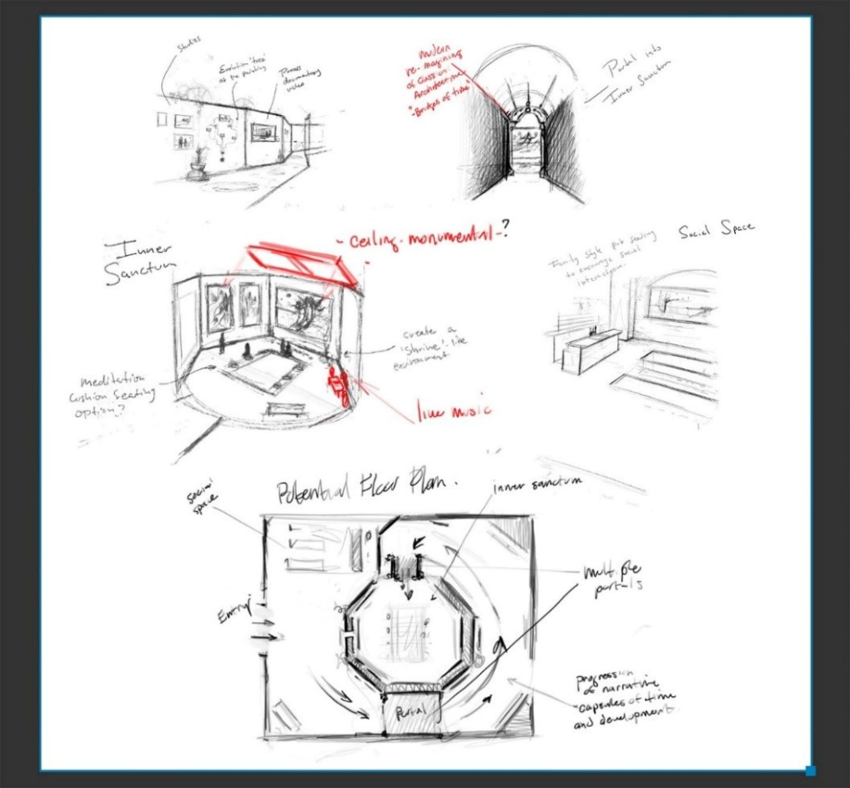

Initial sketches of the exhibition experience
Initial sketches of the exhibition experience
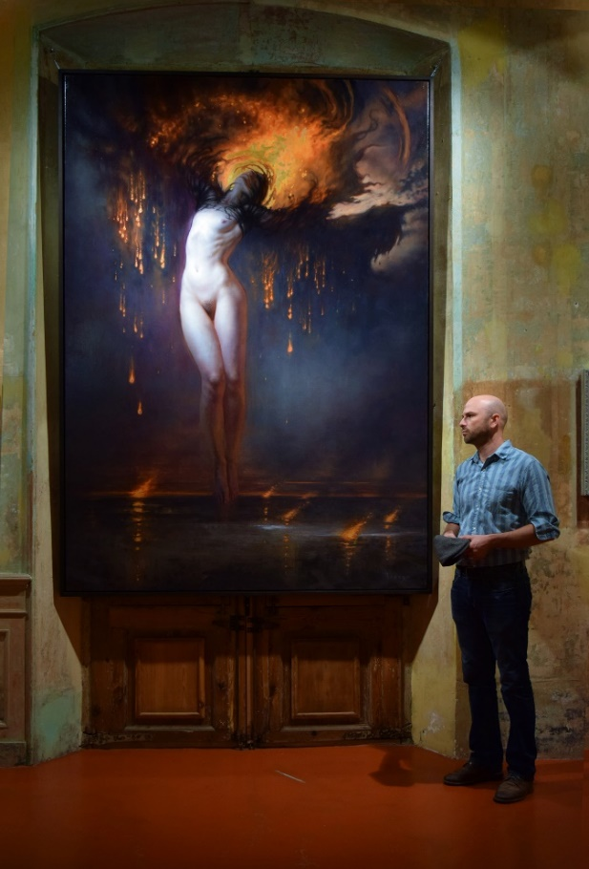
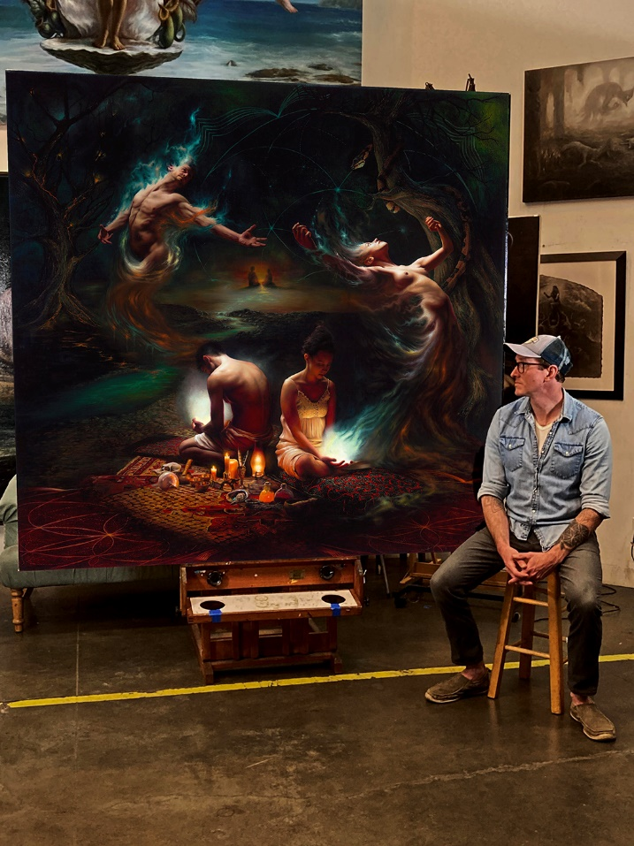
Tenaya Sims with his painting ‘Semillas’ Christopher Remmers with his painting ‘Zain’
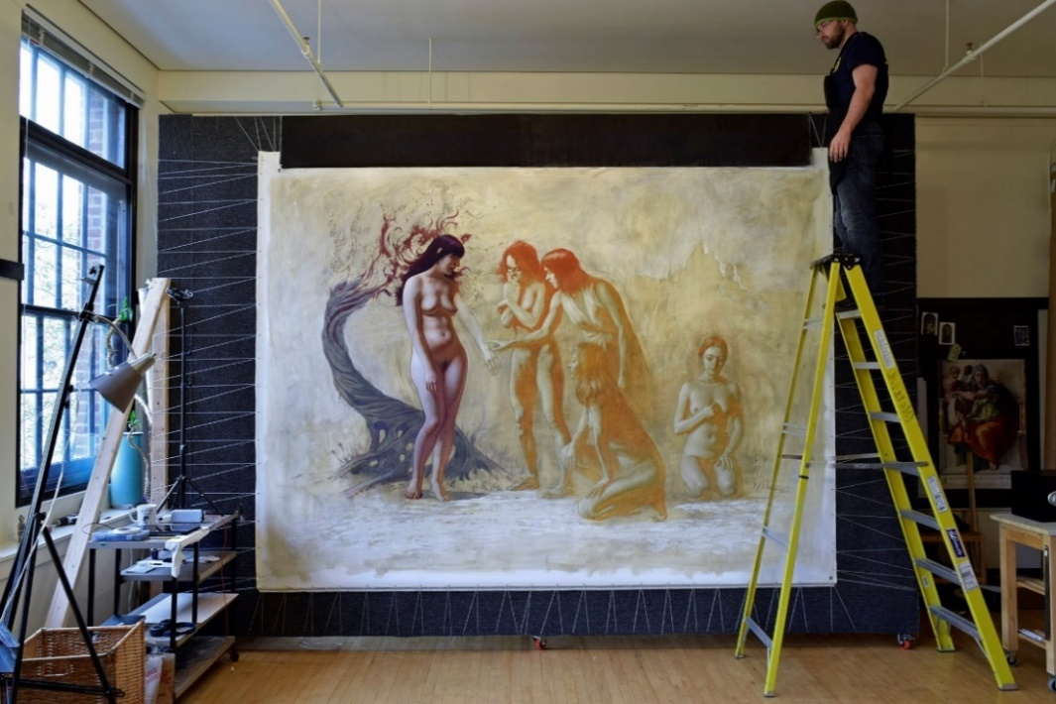

We recently completed constructing our prototype ‘Easel Wall’, which allows works to be created without stretchers. This way we can complete paintings, carefully roll them for transport, and place them on stretchers at the exhibit site.

What’s next?
We are building a team and infrastructure to support this vision. In order to see this through, the next steps are as follows:
- Phase 1
  - Launch fundraising campaign and secure initial deposits
  - Find locations for exhibition
  - Network with supporting cast and allies interested in contributing
  - Roll out initial series of monumental, grand narrative epics!

Education is certainly a pillar of this endeavor. We will create awareness around the potentials of how we experience and engage with art, and open access for aspiring students who wish to participate in this vision.

The Guild
The concept of the artist as a solo practitioner is a fairly modern construct, and contemporary cultural myths help promote the idea of the individual genius over collaboration. Many of the most revered narrative paintings of the Italian Renaissance were not actually executed by a single artist, but rather by a workshop or ‘guild’ composed of apprentices with the master artist at its center.

We, too, believe that a well-coordinated team of highly skilled artists has much larger creative potential than an individual artist alone. We envision that once our we’ve reached our primary objectives, we could reintegrate a guild model of production.
As in the pedagogical systems of Renaissance guilds, the creative production team would be organized into levels of seniority. One source it can draw from is Georgetown Atelier (www.georgetownatelier.com), founded by Tenaya Sims in 2008 as an apprenticeship-style academy specializing in classical drawing, painting, and imaginative realism. In 2018, Christopher Remmers, a former Georgetown Atelier student, joined Tenaya as a Master Teacher in this program. Students who demonstrate exceptional potential within the atelier system could be invited into the Guild.
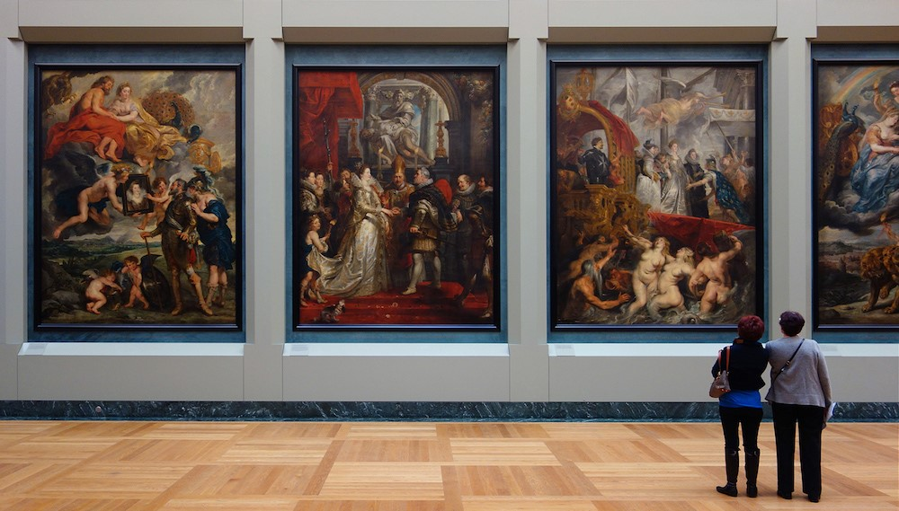
Like many of his contemporaries, the work produced by Rubens' guild typically falls into three categories: those painted exclusively by the artist, those painted partially by him, and those created from his drawings, which while he supervised, were actually painted by his apprentices. While these guilds allowed the master artist to be more prolific, they also enriched the soil for a future generation of artists to blossom. In turn, this hands-on working relationship propelled artists like Anthony van Dyck to develop their own bodies of work and gain recognition in their own right.
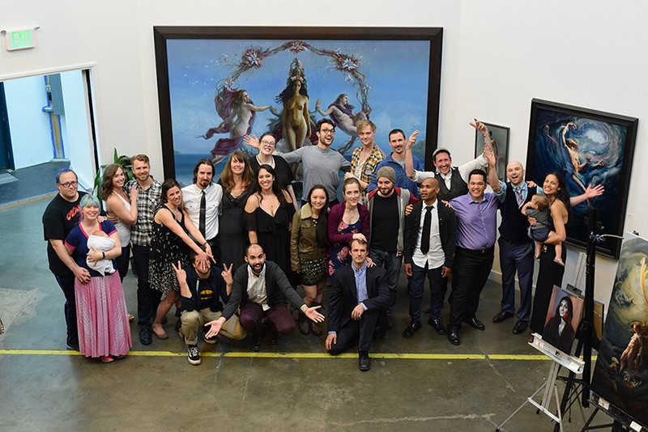
Georgetown Atelier

Join Us
We need your input and expertise in helping to build this new platform for Grand Narrative Painting to reach the public. Additionally, if you are interested in becoming a potential team member, let us know.
We welcome your partnership in this journey.

About Us
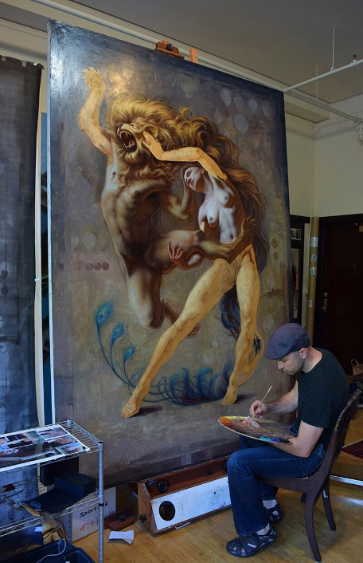
Bio. Tenaya Sims
www.tenayasims.com
Instagram: tenayasims

Tenaya has worked professionally as a teacher, gallery artist, business owner, and industry artist.

After earning his BFA from Carnegie Mellon University in Pittsburgh, PA, Tenaya worked in the video games industry for clients such as Activision and Eidos for several years. He then left the games industry to dedicate five years of full-time study to classical drawing and painting. He attended the Watts Atelier for one year before apprenticing with Juliette Aristides for four.

Tenaya founded his own academy called Georgetown Atelier in 2008. After seven years as an independent organization, Georgetown Atelier merged with Gage Academy of Art in 2016.

Over the past 8 years, Tenaya has exhibited his work at a variety of galleries and venues, including the Salmagundi Club in New York, and the MEAM Museum in Barcelona (as part of the ARC Salon), Abend Gallery in Denver, and a solo show at Krab Jab Gallery in Seattle. Tenaya has also exhibited as a ‘main show’ artist of IX ARTs in Reading, PA in 2017, 2018, and 2019. In 2016, Tenaya won Best in Show for the 12th International ARC Salon Competition.

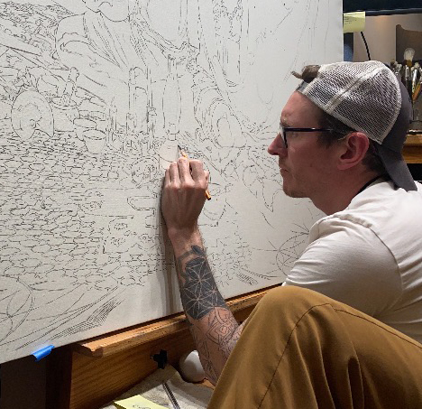
Bio. Christopher Remmers
www.christopherremmers.com
Instagram: christopherremmers

Christopher has been a working professional in the arts for over 15 years. While developing his skill set as a painter he designed and built creative, immersive space through his construction company, Eden Building and Design for over a decade. As a tradesman and contractor Christopher has always gravitated toward projects that possess a sense of artistic craftsmanship and emphasize how we gather in space; what the visionary architect Christopher Alexander describes as “the quality without a name”.

Despite his success, this creative work wasn't able to fulfill his life-long vision to create narrative figure paintings. After years of intensive independent study, Christopher sought out formal training.

In 2013 he began classical drawing instruction with Virgil Elliott, teacher and author of Traditional Oil Painting. He also participated in numerous workshops and courses around the country.

He then discovered the Georgetown Atelier in Seattle, where he enrolled in a full-time, 3-year program with Tenaya Sims. There he learned the skills to manifest large-scale narrative paintings that sent him along the path of imagining a new generation of grand narrative art.

His work can be found in private collections around the world and has been exhibited through 33 Contemporary in Chicago, Abend Gallery in Denver, and as a ‘main show’ Artist at IX for 2017, 2018, and 2019. He is also a 4-time ARC Salon finalist. Currently he is an instructor at Georgetown Atelier in Seattle.
